Install CarboLifeCalc

**1.**

Unzip folder *CarboLifeCalc*

To:

C:\CarboLifeCalc

**2.**

Copy File: *CarboLifeCalc.addin*

To:

C:\ProgramData\Autodesk\Revit\Addins\2017

(Choose which version you want to use it in)

Launch Revit

Accept new plugin and new button will show in task bar:

**3.**

Press the button

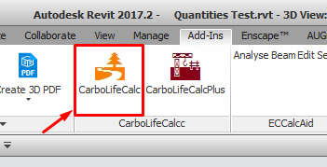

**4. Use interface to calculate Carbon**

